**EIT InnoEnergy brings renewables for cities**

**News 25/11/2019**

[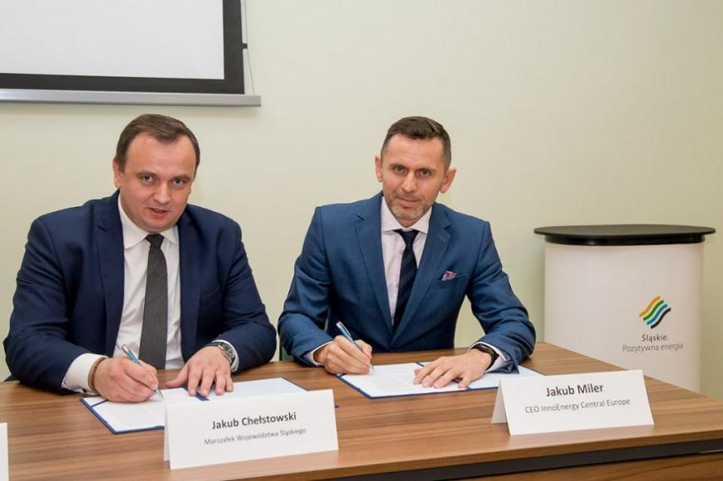](https://eit.europa.eu/sites/default/files/eit_innoenergy_0.jpg)

**In November 2019,**[**EIT InnoEnergy**](https://www.innoenergy.com/)**and**[**Silesian Voivodship**](https://www.slaskie.pl/)**signed a cooperation agreement for the implementation of the 'Better Energy for Cities' project.**

**Clean energy for all Europeans**

Europe wants to be the world leader in renewables and to have a modern energy system that is consumer-centric. To reach the ambitious goals it is necessary to overcome barriers existing in the market. One of them is that of consumer acceptance. This is especially important in coal regions where a large number of people are connected with the coal mining industry and reluctant to change their attitude towards energy sources as this impacts their work. This is also perceived by the European Commission, which proposed some non-legislative initiatives as elements of the 'Clean Energy for all Europeans' package, one of them being the Coal Regions in Transition initiative.

Poland sees the highest employment rate in coal mining (over 99 000), followed by Germany (25 000), the Czech Republic (18 000) and Romania (15 000). Therefore, the main objective of the project is to support chosen Polish coal regions in their path to become modern, innovative and developed. Once EIT InnoEnergy and partners prove it is possible in Poland, they will try to replicate all the developed tools in other regions of the continent.

**Better Energy for Europeans**

BetterEnergy serves as a vehicle for Coal Mining Regions’ citizens to be engaged, conscious and active supporters for the outlined transitions.

The project involves conducting a modern communication and education campaign, as well as develop and provide all the necessary business, legal and technological support tools to empower the citizens of the coal mining regions in Poland to make the full journey from being a passive consumer to an active participant. The ultimate goal is to prove that such a campaign is an efficient tool to drive the transformation of the regions and build a framework for the next waves of similar campaigns in other coal mining regions across Europe.

**The project is planned to be implemented in three major parallel streams:**

* Communication & education campaign
* Dissemination and communication actions
* Creating a framework for the project’s replication in other European regions.

**Cooperation with Silesian Voivodship**

The Marshal of the Region, Jakub Chełstowski, as well as InnoEnergy Central Europe CEO, Jakub Miler, and Public Affairs Manager, Kamil Szydłowski, participated in the deliberations.

*One of the tasks of the Team is to build interregional cooperation within the platform, which in perspective is to help in creating new development opportunities, including towards the transformation of the energy system, as well as eco-innovation and care for clean air and the environment. We want to activate local governments affected by the issue of mining transformation to greater synergy in cooperation between entities. There are many interesting works ahead of us. I believe that we are in the right cooperation environment.*

*Jakub Chełstowski, Marshal, Silesian Voivodship*

The project, which will be implemented jointly with the Voivodship, is of an educational and informative nature and involves the use of a methodology for achieving an appropriate degree of awareness of citizens, which will allow efficient and independent conduct of energy transformation in the immediate environment of each of us.